**AN IMPROVED ADAPTIVE BEAMFORMING ALGORITHM FOR**

**5G INTERFERENCE-COEXISTENCE COMMUNICATION**

**ABSTRACT:**

Multiple wireless systems coexisting in a 5G network might produce interference in the same frequency band, degrading the received signal's performance. In this paper, a novel algorithm is proposed in antenna array processing to handle interference-coexistence communication. We adopt a linear filter which is called Linearly Constrained Minimum Variance (LCMV) filter. We impose a log-sum penalty on the coefficients and add it to the cost function based on classic singly linearly constrained least mean square (LC-LMS). The iterative formula for filter weights is derived. We demonstrate that the new method's convergence rate is faster than the traditional one using simulations in an antenna environment with a signal of interest, noise, and interferences. Furthermore, the proposed method's mean-square-error (MSE) is confirmed. Our technique has a lower MSE than the classic LC-LMS algorithm, according to the findings of the experiments. The suggested adaptive beam forming approach can be used in a 5G system to deal with signal and interference coexistence.

**EXISTING SYSTEM:**

Least Mean Square(LMS):

In adaptive filtering applications for modeling, equalization, control, echo cancellation, and beamforming, the widely used least-mean-square (LMS) algorithm has proven to be both a robust andeasily-implemented method for on-line estimation of time-varying system parameters [7]. Fig.1 shows a generic adaptive beamforming system which requires a reference signal, the outputs of the individual sensors are linearly combined after being scaled using corresponding weights such that the antenna array pattern is optimizedto have maximum possible gain in the direction of the desired signal and nulls in direction of interferers .

The LMS algorithm can be described by the following three equations,

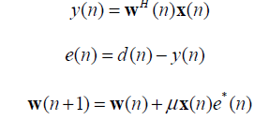

Review of LC-LMS Algorithm:

LC-LMS algorithm was proposed to adjust coefficients of the array in real time. Here, we make an short review of the algorithm. Let y(n) be the observed output of antenna array



Where is the estimated filter coefficient vector, is the array input vector. Then the desired output d(n) isexpressed as  In the above equation, wo is the optimal coefficient vector and N(n) is the observation AWGN with zero mean and variance. The LC-LMS filter aims to minimize the output power and maintain the response of the SOI. The optimization problem can be written as

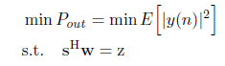

where s donates the M *1 steer vector of SOI and z is the constraint. The output power can be expressed as



We use instantaneous covariance R to replace Then the cost function is defined as .The steepest descend method is used to get the solution of w(n)



In equation (8), is the step factor. By substituting (7) into (8), iteration expression of (8) can be rewritten as



Where 

To make the algorithm converge to optimal value,  should satisfy the condition



is the max eigenvalue of R. In addition, combining and we can get the optimal solution



Here, modulus value of coefficient w(n) to show the convergence rate. Steady state is characterized by MSE.

**DISADVANTAGES:**

1. The LMS algorithm has a slow convergence rate and its slow convergence presents an acquisition and tracking problem for cellular systems.

2.LC-LMS algorithm is not effective in the case of convergence rate

3. LC-LMS algorithm is also not effective in the case of steady state.

**PROPOSED METHOD:**

On the basis of traditional ,singly linearly constrained least mean square (LC-LMS), we introduce a log-sum penalty on the coefficients and add it into the cost function. We derive the iterative formula of filter weights.By simulations in antenna environment with signal of interest, noise and interferences. In this part, we give the specific derivations of the new algorithm. The newly proposed algorithm adds log-sum penalty to the object function on the basis of LC-LMS. The optimization problem is expressed as follows

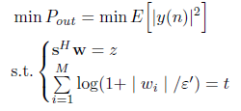

 is the i-th element of the vector w(n).  is a parameter that determines how much each element contributes to the penalty t. Then the Lagrange function can be written as

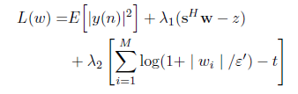

Similarly, through steepest descend method, we get



Where and Pre-multiplying equation (14) with and using the constraint 





In order to reduce the complexity, we make an approximation



The approximation is on the basis of  n is large enough. Now we define and make another approximation



Then pre-multiply equation (14) with and eliminate w(n + 1)

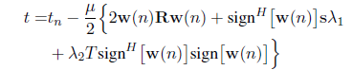

Where   can be denoted as

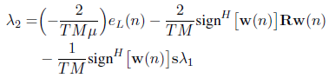

Where ), we can obtain the solutions of Finally, can be rewritten as

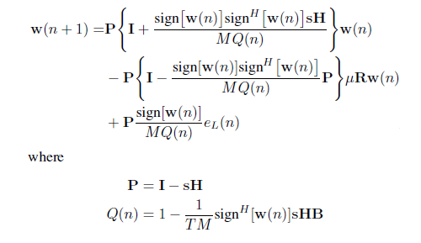

**ADVANTAGES:**

1. Log Sum LC-LMS algorithm has fast convergence rate.

2. Log Sum LC-LMS algorithm has lower MSE(Mean Square Error).

3. Log Sum LC-LMS algorithm is well suited for interference-coexistence communication.

**APPLICATIONS:**

1 Applied in 5G system.

2. System Identification.

3.Inverse Modeling.

4.Prediction.

5.Echo Cancellation.

**Software & Hardware Requirements:**

**Software:** Matlab R2018a.

**Hardware:**

**Operating Systems:**

• Windows 10

• Windows 7 Service Pack 1

• Windows Server 2019

• Windows Server 2016

**Processors:**

Minimum: Any Intel or AMD x86-64 processor

Recommended: Any Intel or AMD x86-64 processor with four logical cores and AVX2 instruction set support

**Disk:**

Minimum: 2.9 GB of HDD space for MATLAB only, 5-8 GB for a typical installation

Recommended: An SSD is recommended a full installation of all Math Works products may take up to 29 GB of disk space

**RAM:**

Minimum: 4 GB

Recommended: 8